PHASE 4: Process Automation (Admin)
Debug Log Analysis and Bug Fixing in Salesforce Apex

1. Objective of Phase 4
Although this project mainly focuses on Apex programming and debugging, basic admin-level automation is required to support test executions, logging, and code behavior verification.
In this phase, we configure Salesforce automation tools—Flows, Validation Rules, Assignment Rules, and Debug Log settings—to ensure that Apex code executes correctly and produces replay-enabled debug logs for analysis.
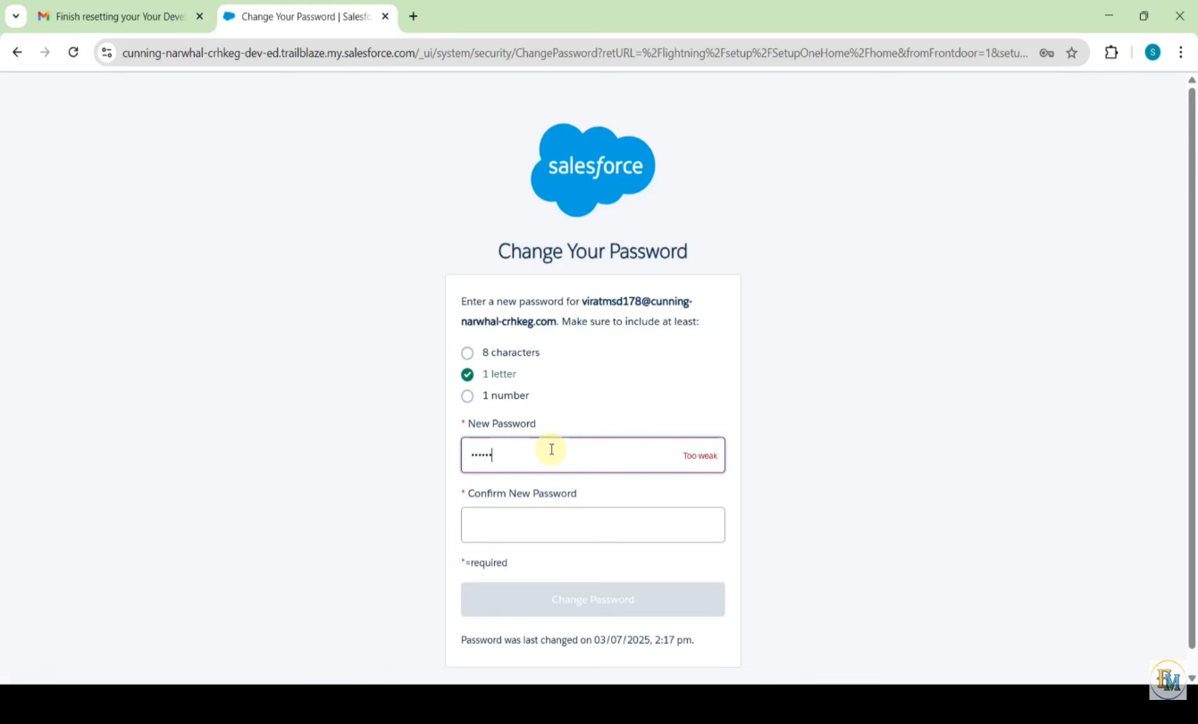

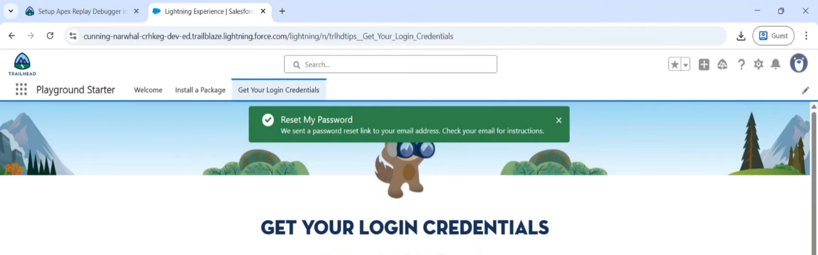

2. Debug Log Automation
Replay Debugger requires continuous and consistent debug logs. Therefore, admin automation includes:
a. Creating a Trace Flag
- Navigate to: Setup → Debug Logs
- Add your user in "Monitored Users"
- Set log levels:
  - Apex Code = FINEST
  - Visualforce = FINER
  - System = FINEST (optional)
This ensures that every Apex test produces a replay-enabled log.
b. Setting Auto-Expiration
- Trace flags are valid for 30 minutes
- Admin settings help auto-refresh logs when needed
Purpose:
To make sure every time you run the Apex test, the system automatically generates detailed logs needed by the Apex Replay Debugger.

3. Optional Flow for Pre-Populating Account Fields
Although this project uses Apex to create accounts, a simple Flow can be configured to:
- Pre-fill Account fields
- Validate data before Apex executes
- Ensure consistent input values for debugging
4. Validation Rules (Optional)
Validation rules are created to ensure that:
- Required fields are not empty
- Test data is consistent
- Apex failures are not caused by bad input
Example:
TickerSymbol must be exactly 3–5 characters.
This helps Apex tests run smoothly without unexpected validation errors during debugging.

